­­­­­

Download

Upload

Login

Profile Admin

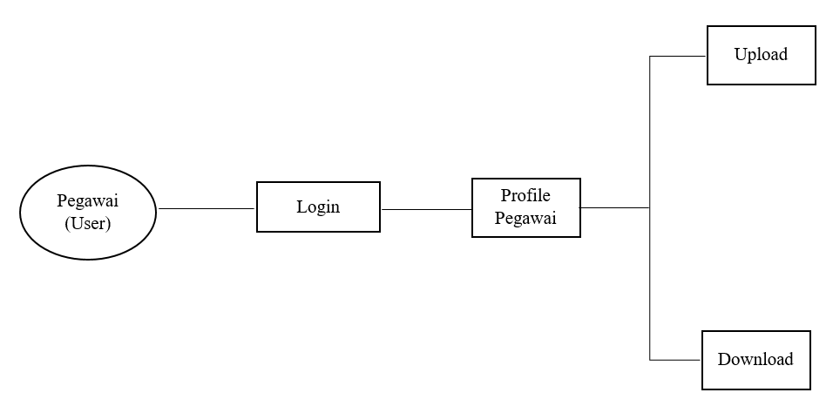

Use Case User

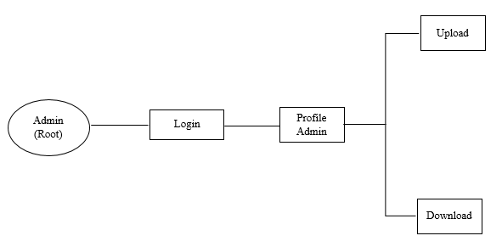

Use Case Admin